Gary A. Christopherson  Speaking Topics  Building a Thriving Future  - Thrive! ®/ Thriving Future - Creating and sustaining a thriving future for specific and cross-cutting issues and for “communities” (local, State, national, regions, global). www.ThrivingFuture.org  - viaFuture – Creating and sustaining large, positive change to help build a healthy America/world, reduce vulnerability, fix broken policies and programs, and build a thriving future. www.viaFuture.org  - via Strategy - Moving mission-driven, complex organizations to achieve their vision and high performance via a living and executable strategy, and effective strategic and operational management.  Improving Health & Health Care  - HealthePeople® – Achieving a healthy and thriving future via a reformed “health” system (insures all, reduces cost, improves quality, “person-centered”, “e” enabled). www.HealthePeople.com  - National Health Reform - Strategies for affordable, accessible, quality and transformed health system with and beyond 2010 Health Reform law.  - Federal Role in America’s Health – Views of one serving in senior-level positions with the White House, Congress, and three Departments (DHHS, VA, DoD).  - Person-centered health – Person-centered care and person-provider partnerships.  - Un- and Underinsured – Strategies exist to “solve the problem”.  - High Quality – Moving health systems/ providers to high quality/performance.  - Behavioral Effectiveness – Health’s future depends on supporting healthy behaviors.  - US virtual health system - Synergy of standards, electronic health records, personal health records, exchange.  - Electronic health record systems – The future EHR and PHR systems and their impact on health and health care.  Reducing Vulnerability  - Vulnerable (via) – Collaboratively pursuing a new national policy strategy for reducing vulnerability in America and globally. www.VulnerableInAmerica.org | Biography  Throughout career, he worked on strategic and operational planning, policy, systems, models, management, reform and performance to reduce vulnerability, improve health and build a thriving future.  He founded Thrive!® to help create, manage and sustain large positive change and build a thriving future for all (persons, local, State, regional, national, global). www.ThrivingFuture.org He founded HealthePeople® help build a healthy and thriving future for persons and communities (local, State, regional, national, global). www.HealthePeople.com He published Thrive! - Building a Thriving Future.  This draws from 30+ years of experience in creating, managing, and sustaining large scale change at national and local levels in public and private sectors.  Most recently, he served as Senior Advisor to Chief Operating Officer, Centers for Medicare & Medicaid Services and Senior Advisor to VA Under Secretary for Health. He led CMS’ Strategic/Operational Plan effort and also focused on person-centered health and pay for performance.  For VA, he led initiatives, incl. person-centered health, personal health systems, virtual health systems and standards. He led HealthePeople, an initiative to improve health info and health delivery systems.  Currently, he is a Fellow of the National Academy for Public Administration. In 2004-05, he served as Senior Fellow with Institute of Medicine.  Beginning in 2000, Gary served as Chief Information Officer (CIO), Veterans Health Administration where he managed and upgraded the $1+ billion health info system for the $20+ billion veterans health system.  Until 2000, he served with the Department of Defense, including as Principal Deputy Assistant Secretary and Acting Assistant Secretary for Health Affairs. He managed the $15+ billion Military Health System.  In 1993-94, he was Associate Director, Presidential Personnel at the White House and managed Presidential appointments for HHS and eleven other Departments.  Earlier, he was Director, Health Legislation, U.S. House Select Committee on Aging. | 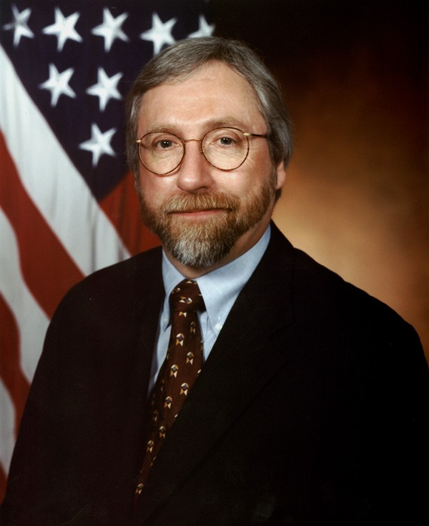  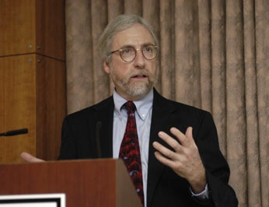  Testimonial  “Gary Christopherson is an engaging and thought-provoking presenter. He is consistent in providing our delegates with valuable ideas and strategies that change the way they view healthcare.”  Colleen Craig  Conference Manager  World Congress  Leadership Summit Series  Gary is also a sculptor of abstract art, focusing on mobile and stabile sculptures. Over the years, he has created over 150 sculptures, primarily working in wood and copper as media. www.GChris.com  He is the author of two science fiction novels and two children's books. www.Amazon.com

