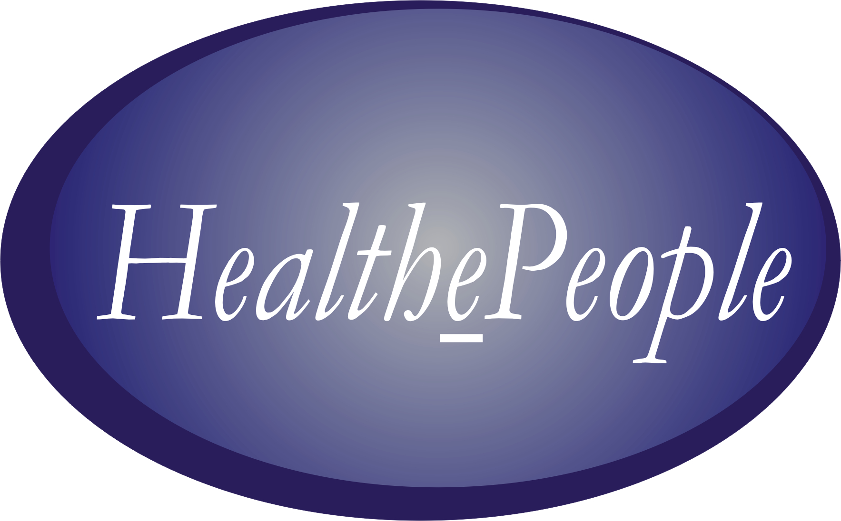
HealthePeople: Person-Centered, Outcomes-Driven, Virtual Health Systems

Gary Christopherson

HealthePeople is our vision of better health for all—and a collaborative strategy to transform to person-centered, outcomes-driven health systems. This strategy is built to realize three goals. Our first goal is to improve and achieve a high state of health. This involves more than medical interventions or traditional healthcare services; it requires a full range of resources from across the community and beyond. Second, its focus is on people—consumers, patients, enrollees, and members. They are the center of the health universe and must be treated as such, forming strong partnerships between individual patients and their healthcare providers. Third, creating this new healthcare universe requires what we call the enabling “e”, the electronic capabilities provided by
- Adopting national health information standards
- Making available personal health record (PHR) systems
- Supporting health information exchange (IE) when authorized and appropriate
- Greatly increasing the affordability, availability, and interoperability of high performance, standards-based electronic health record (EHR) systems.

We are already implementing the HealthePeople strategy to improve the health of 26 million U.S. veterans served by the Veterans Health Administration (VA). Our successes there have led us to a vision that is much grander in scale—a vision of a person-centered “virtual health system” that better serves the health needs of many, many more Americans.

Succeeding with HealthePeople across potentially 100 percent of clinics, hospitals, nursing homes, community-based care centers, and integrated health systems will transform health care in the United States. In essence, it will “electrify” 1/7th of the U.S. economy—about $1.8 trillion in 2004. This transformation will change the healthcare landscape as surely as the Rural Electrification Act of 1936 changed the national economy when it brought electrical power to farms and small towns across the country, improving the quality of life and increasing the productivity of rural America.

The enabling “e ”and the electronic capabilities it provides are critical to the creation of virtual systems and their components—standards, EHRs, PHRs, and IE. Such virtual health systems are valuable beyond just national use. They are valuable for communities. They are valuable for linking together primary care physicians, subspecialty physicians, and hospitals. And they are valuable for individuals committed to self care.

While some may question the feasibility of achieving a virtual health system nationwide, we believe that the United States has reached the “tipping point” in the creation of this system. For this reason, we recommend strategies for achieving a paperless, person-centered, outcomes-driven, virtual health system by the year 2010.

Transforming to Person-Centered Health Systems

A virtual health system offers the best means to optimize health care and maximize people’s health and ability. For 26 million veterans and their providers in the VA, much of this future is close at hand. Going beyond the VA and reaching essentially all persons and their providers will likely require much of the rest of this decade.

It is well worth the effort. Person-centered health systems are different. They address health differently; they organize differently; they operate differently; they use information differently; they use their scarce resources differently; and they function best when enabled by high performance health information systems. To illustrate, we offer several vignettes within and across care settings.

Coordinating Care

As part of the clinic team, a care coordinator is responsible for a large number of patients, ranging the well to the severely chronically ill. He uses the “electronic dashboard” on his computer screen to access the records of the patients he serves and to display the full array of health services available to patients registered at the clinic. On a day-to-day basis, he uses the service array to optimize scarce resources in producing target health outcomes. Via his electronic dashboard, he orchestrates a virtual health service delivery system that blends clinic-based and community-based services to improve the health of the patients he serves.

Managing Appointments

A patient makes and checks appointments any place and any time using the Internet and/or telephone. Using real time scheduling, his primary care team matches their appointment schedule and his needed and/or desired visit. The scheduling system allows advanced access appointment making and provides decision support that optimizes appointments for patient and staff alike. To conserve patient time and scarce clinic resources, the system times the appointment to meet multiple healthcare needs during a single visit.

Optimizing Clinic Visits

Before his scheduled clinic visit, a patient updates his health and demographic information from home or workplace using phone or computer. When he enters the clinic building, he is electronically recognized and the clinic is notified of his arrival. His electronic record is uploaded, staff move into position, and ancillary services are prepared. He goes directly to an available exam room or ancillary service to start care. Subsequent parts of the visit are optimized based on his needs, his progression through the visit, and the availability of resources. All information, including specialty consultations (provided via telehealth if needed) necessary for diagnosis and treatment, is obtained during the visit. Treatment is initiated prior to departure; prescriptions are waiting at the end of his visit or are already scheduled for quick delivery to his home or workplace. He electronically indicates satisfaction with his visit before his departure; if there is a problem, service recovery occurs before he leaves. Following the visit, the patient reports on his progress with the therapeutic interventions timed to clinician-initiated guidelines. Except when a clinic visit is necessary, he receives ambulatory care and eHealth services (telephone- or internet-based) in his home or workplace.

Optimizing Clinical Care

Entering one of the exam rooms to which she has access, a clinic physician carries a portable, wireless electronic device that moves with her throughout the clinic day after a single sign-on. All information on the patient from any authorized source is available real-time in computable form using standardized data. During the exam, all vital signs are automatically entered into the patient’s health record by the respective medical device. A tablet computer is used for data entry and patient education. If a specialty consultation is needed, the physician can access a sub-specialist locally or in other parts of the nation. She orders ancillary services electronically, and they respond directly, minimizing patient time and inconvenience and optimizing clinic resources. In the future, the physician will use speech recognition, a wearable computer, and a head-mounted monitor to record and display information and allow “hands-free” handling of data input/output.

Reducing Health Risks

A health plan member uses her personal health record to complete a health risk assessment online or at her closest health facility. She then shares the information with her primary care team, works with them to set up a risk factor management strategy, feeds her risk reduction progress to her primary care provider, and receives reinforcement via electronic messaging. When behavior change is needed, she uses her health plan’s electronic risk factor reduction program and/or enrolls in phone or online peer-to-peer support groups assisted by her plan’s health staff. This information is recorded in her PHR and in her health plan’s EHR.

Sharing Information

A health plan member has a primary care physician, receives chronic disease care from a sub-specialist, uses a teaching hospital for any needed inpatient care, worries about needing emergency care while on a hiking vacation, and accesses health information and services via the Internet. Via a nationwide health information exchange system and in real time, she uses the Internet to make appointments and get trusted information, share her health record with her primary and subspecialty care physicians and with her hospital when hospitalized, retrieve her health record for use by the emergency physician treating her hiking injury. Healthcare providers all have high functioning electronic health records that support care in those care sites and can send, receive, and use information shared with her and with other providers. Any information sharing is subject to privacy requirements, standards, encryption, authorization, and authentication.

Supporting a Person and Involving Family and Friends

A chronically ill veteran gives his family and friends access to his PHR, so they can help him make appointments, refill pharmacy scripts, and get trustworthy information. In short, they use his PHR as a family support tool, becoming informal members of his primary healthcare team, effectively extending the team’s resources. On occasion, his family and friends engage in internet dialogues with his health advisors, or form peer-to-peer and family support groups. They rely on the PHR as a source for information on the facilities he uses and on his benefits, including registration and application requirements. All these efforts contribute to better person-centered care.

As these vignettes illustrate, virtual health systems, building on existing provider health systems, empower individuals to participate in improving their health and to partner with all their healthcare providers.

Optimizing Health Systems and Maximizing Health and Ability

Maximizing the health and ability of people—the insured, under-insured, and uninsured as well as America’s veterans—requires that our health systems operate as close to the optimum as possible. At the service, facility, community, and regional levels, our systems must move beyond episodic care. They must coordinate the whole care of the person and the care of populations, whether they are defined by disease, functional status, risk status, or health plan enrollment. Care needs to be coordinated and delivered not just to the acutely or chronically ill, but also to those who are well. When there are care episodes, all evidence-based care needs to be brought to bear and delivered in an optimal manner. Few, if any, health systems today operate even close to optimally.

Health systems need to work within their walls and in collaboration with other health systems and academic institutions to determine best practices based on outcomes and to apply them rigorously. But this will not be enough. Current best practices may not be the best that can be done; we may need to design more “ideal” systems, systems that operate optimally to maximize health and ability at all levels—episode, person, and population. Further, health and information technology must be applied effectively to support these best practices and ideal systems.

Coordination of care using best practices and ideal health systems enabled by high performance health and information technology will move us toward more optimized health systems producing substantially better health outcomes, as shown in Figure 1.

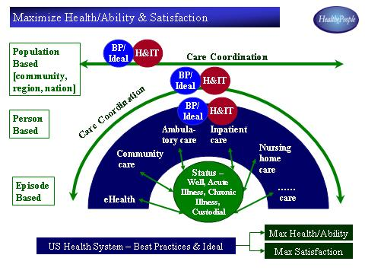 FIGURE 1 – MAXIMIZE HEALTH/ABILITY AND SATISFACTION

Even this will not be enough. Maximizing health requires going beyond the limitations of what any healthcare system can do by itself. The key is the person. For this effort to succeed, the person is and must be treated as the center of the health universe. To the extent possible, that person should engage in healthy behaviors and conduct self care using reliable information and proven health supplies, medications, and other health aids. In addition, the person should exercise choice in selecting health providers and partner with them as an active participant in the healthcare process.

Optimal care for the person and for populations and communities demands the use of outcomes-based measures for prevention and wellness, and the adoption and ongoing re-definition of best practices. Maximizing health and ability requires more than health information systems, and valuable work is being done to address these medical challenges.

We believe the use of affordable, high-quality, standards-based health information systems can help create virtual health systems, enabling substantial health improvements here in the United States and in other countries around the world. This is the heart of the HealthePeople concept and our focus in this book.

Creating a Virtual Health System

The HealthePeople concept places the person firmly at the center of the virtual health system. Supporting that person and serving as the foundation for the system are electronic health record systems. EHRs are essential. Without them, personal health record systems contain little of value, information exchange has little of value to share, and standards have limited applicability. Still, EHRs alone are not sufficient to transform health care. It is PHRs that bring the person into a more active role in improving health, and it is information exchange that enables information to flow where it is needed—to the person for personal use, to the emergency room outside the person’s provider system, to a person’s primary healthcare provider engaged in an outside subspecialty consultation, or to a new provider when a person moves, either short or long term.

For information to be clinically meaningful, there must also be standards to ensure that “language” is the same across providers. Standards are essential to moving health information, as appropriate and authorized, by the person, primary provider, and other providers. Standards also allow the sharing of de-identified information with public health systems, including the Centers for Disease Control and state and local health departments, for disease surveillance.

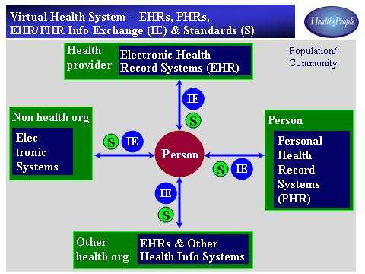

FIGURE 2 – VIRTUAL HEALTH SYSTEM

As shown in Figure 2, four components are key to the creation of a virtual health system: electronic health records, personal health records, information exchange, and standards. The HealthePeople strategy builds upon all four and offers models for what these individual components should be and how they should operate.

Electronic Health Record Systems

EHR systems are the foundation for the virtual health system. The other components cannot function effectively without them. Thus, we must implement EHRs in this country’s clinics, hospitals, community-based care, and integrated health systems. Our goal is to come as close to 100 percent as possible by the year 2010. We know this is very, very ambitious. We also know it is possible.

It is possible because we already have functional models defining and setting the standards for an EHR. Such models are being developed by the health community in initiatives involving both private and public sector organizations. One major effort is being coordinated by the Institute of Medicine (IOM) and the health standards group Health Level Seven (HL7). Participants from the public sector include the VA, the Centers for Medicare and Medicaid Services (CMS), the Agency for Health Research and Quality (AHRQ), and the Assistant Secretary for Planning and Evaluation in the Department of Health and Human Services (HHS). Private sector representatives come from the Health Information Management and Systems Society (HIMSS) and the Robert Wood Johnson Foundation.

Within our vision of HealthePeople, high performance EHRs collectively support the full range of functions and settings for health care, including public health. The range of functions includes health data storage, clinical tools (clinical interface, clinical reminders, clinical guidelines, access to current medical/health information), and analytical tools (management, research). The range of settings reaches across the full spectrum of care: integrated health systems, community-based care (home and workplace), ambulatory care, inpatient care, nursing home care, primary and specialty care, mental health care, emergency care, laboratory, radiology, pharmacy, and rehabilitation.

Such EHRs exist today at leading institutions in the private sector. In the public sector, the VA’s systems have a high level of functionality and will offer progressively higher levels over the next several years.

Although the VA’s EHR is not functionally different from any other high performance EHR, it stands as a proof of concept. It demonstrates what EHRs can do and how they can work in the varied settings that make up the VA, America’s largest integrated health system, ranging from small clinics and nursing homes to large research hospital. Figure 3 depicts a potential model, high performance health information system, based on VA’s HealtheVet/HealthePeople-VistA.

A few private sector software vendors have high performance EHRs. More could offer such a system as a single suite of applications, either from a single vendor or a number of different vendors. As part of the HealthePeople vision, we strongly encourage vendors to make such highly functional systems available in all these different settings.

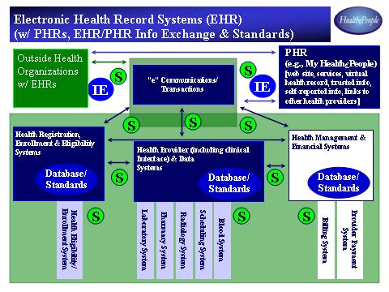

FIGURE 3 - ELECTRONIC HEALTH RECORD SYSTEMS (EHR)

Personal Health Record Systems

Building on the EHR, personal health record (PHR) systems allow individuals to manage their own health care. Within the HealthePeople vision, PHRs enable persons to access their own health records and to link those records, if they choose, with records from multiple healthcare providers. Individuals are able to record and share their personal health information, such as weight, blood pressure, glucose levels, pain, and tobacco and alcohol use. The PHR gives people access to trusted information and helps them link up with support groups and other resources to help maintain and improve their health. PHRs also assist individuals with health-related tasks such as making appointments, filling prescriptions, and making co-payments. These capabilities are provided via secure use of the Internet and other appropriate technologies.

This concept works, and there are models for a PHR, developed and tested in the VA. The first working model, My HealtheVet, had many of the functions a strong PHR should have; this PHR was used by 14,000 veterans. The next version, My HealthePeople, offers a model of how a PHR system could function and interoperate with EHRs using information exchange and standards. The VA is continuing to build upon their experience to refine the functions that PHRs provide to individuals; these services are listed in Table 1.

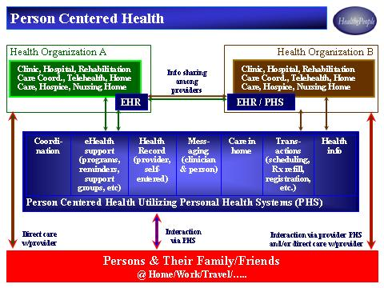

FIGURE 4 – PERSON CENTERED HEALTH

TABLE 1 – PERSONAL HEALTH SYSTEM/RECORD (PHS/R) CAPABILITIES

Health Record
- Access part of or whole VHA EHR
- Self-enter personal health information
- Share veterans’ VHA EHR w/ non-VHA health provider(s)
- Share non-VHA health provider(s)EHR w/ VHA
- Share veterans’ VHA EHR w/ family or “delegate”

Messaging (with health provider)
- See Health Support services for messaging opportunities

eHealth Information
- Receive trusted information via access to general source
- Receive trusted information via VHA programs and facilities
- Access links to non-VHA sites (disclaimer by VHA)

Automated eHealth transactions
- Check and/or fill prescriptions
- Check, confirm and /or make appointments
- Check co-payments [Considering make co-payments]
- Register for benefits or communicate changed registration

eHealth Support
- Self-assess health (e.g. self-monitoring; identify health problems)
- Access appropriate, basic “diagnostic/therapeutic” tools
- Monitor health (e.g. report blood pressure, glucose, pain, weight)
- Participate in sponsored support or discussion groups
- Receive health behavior reinforcement
- Have telehealth consult with health provider
- Access safety services (e.g. drug-drug interaction checks)
- Receive electronic reminders (e.g. taking pills; appointments)
- Use “check in”, for those living alone and at risk
- Bi-directional question/answer between clinicians and veterans
- Receive notification of non-sensitive test results
- Track progress on treatment

Despite these promising advances, PHRs remain relatively immature at this time. There must be a substantial amount of public-private sector collaboration and development to make a good PHR system available to everyone who wants one.

Health Information Exchange

Health information exchange (IE) is the capability and the associated system or systems to securely and effectively exchange information among the person, the primary health provider, other health providers, and other health organizations (public health, payers, quality improvement) when appropriate and authorized. In the health sector today, exchanges tend to be limited and bilateral in nature, for example, between two health providers, between a person and his/her primary health provider, between a health provider and a payer, between a health provider and a public health agency, and so on. These differ markedly from multilateral exchanges, as Figures 5 illustrates.

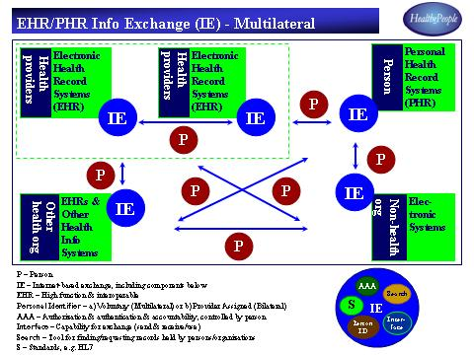

FIGURE 5 – EHR/PHR INFORMATION EXCHANGE

There are efforts trying multilateral approaches at the community level and a couple of efforts are experimenting on a larger scale. Achieving the health information exchange capability essential to greatly improve health requires a quantum leap. Efforts to implement multilateral approaches at community and regional level are helpful, but there must be a much greater speed of development and rate of adoption.

A complementary approach is enable EHR and PHR health information exchange similar to the Internet or the banking system, each of which offer working models that incorporate a wide range of users and functions. Such a system might be as follows:
- Provide multilateral capability across persons, providers, and other health organizations.
- Utilize HL7 messaging as the standard for moving messages among the users.
- Employ authorization and authentication systems to ensure that only authorized persons/providers exchange authorized information.
- Provide EHRs on both ends of an exchange that have the functionality to share (send and receive/use) information.
- Use encryption to secure the exchange system if we are to obtain and sustain the trust of users.
- Provide an identifier (possibly a voluntary ID similar to what we do with phone numbers and email addresses) so that we can ensure that we have the right person’s health information to be shared.
- Leverage the infrastructure provided by the Internet and its ability to move information securely and effectively.

Standards

After decades of work, standards are being adopted by the federal government and by many other public and private sector organizations. Table 2 provides a current list of standards that have been approved by the federal initiative known as Consolidated Health Informatics (CHI).

TABLE 2 – CONSOLIDATED HEALTH INFORMATICS (CHIS) STANDARDS ADOPTED

- Laboratory Results Names – LOINC
- Messaging Standards – HL7
- Messaging Standards – NCPDP SCRIPT
- Messaging Standards – IEEE 1073
- Messaging Standards – DICOM
- SNOMED CT for Interventions and Procedures (non-lab), Laboratory Result Contents, Anatomy, Diagnosis/Problem Lists, Nursing
- HL7 for Demographics, Units, Immunizations, Clinical Encounters, Text-based Reports (Clinical Document Architecture)
- Interventions/Procedures – Lab – LOINC
- Payment – HIPAA Transactions and Code Sets
- Genes and Proteins – Human Genome Nomenclature (HUGN)
- Chemicals – EPA-s Substance Registry System
- Medications – Active Ingredient (FDA Ingredient and UNI Codes); Clinical Drug (Rx Norm); Manufactured Dosage Form (FDA Standards Manual); Drug Product (FDA NDC); Medication Package (FDA); Label Section Headers (LOINC SPL); Special Populations (HL7); Drug Classifications (National Drug File Reference Terminology (NDF-RT)

While there are many areas for standards, we focus on five areas: health data, health information exchange, security, EHRs, and PHRs.

Health data standards, in terms of a common language and common terminology, are critical across health providers and within large health systems. They include LOINC for laboratory, SNOMED for a broad range of clinical terminology, and NCPDP Script for drugs. In the future, we will move beyond terminology to have robust reference models in key areas such as drugs. Data standards support a wide range of decision support needs such as drug-drug and drug-allergy interactions, clinical reminders, and visual displays of laboratory results and vital signs. Such standards help ensure that information from multiple sources is clinically meaningful and comparable.

With respect to health communications, standards help ensure that information can be moved between health providers (e.g., HL7) and between medical equipment and EHRs (e.g., DICOM for imaging and IEEE 1073 for medical devices). As a potential solution for health information exchange is developed, additional standards will likely be needed.

Functional models and standards for EHRs are needed to guide vendors, providers, and payers to what functionality is needed, for what setting, and when. The key is to determine what functions (e.g., ordering, a longitudinal record, a clinical interface, decision support, interoperability with other EHRs) are needed for different care settings (clinics, hospitals, nursing homes, care in the community, public health, and integrated health systems) and when (what should be core to a good EHR in the near term; what should be the future progression of this core in the longer term; what should be the desired functions in an “ideal” EHR for the long term). These standards focus on what functions a good EHR should have and not on how those functions are delivered by a particular vendor.

Much of the work now being done on EHRs should help guide the development of standards and models for PHRs, even though the two types of records are substantially different. Standards for both records are critical to the high levels of functionality and interoperability a virtual health system requires.

The Challenge

Achieving positive, large-scale change is not simple or easy, but it can and must be done. Success requires recognizing complexities of the environment in which change must occur and of the key players who can bring about quantum-level change.

Until about 2001, relatively little had been achieved nationally or internationally to accomplish the changes demanded by modern health practice, healthcare providers on the front line, and individuals wanting and needing to improve their health. That is not to say that a lot of good work had not been done. The contrary is the case: Much of what is being achieved today and will be accomplished in the days ahead is heavily dependent on the pioneering work of the past two decades.

In the United States and around the world, there are hundreds, perhaps thousands, of health information systems and health information standards. The lack of standardization for health data and for communicating health records makes it extremely difficult to share health information. As Figure 6 illustrates, the result is a very complex environment, where healthcare organizations often recreate and reinvent health information systems at great expense. This situation persists despite the fact that the delivery of health care is very similar, regardless of the particular settings, across healthcare organizations, and that data and communications needs are also very similar.

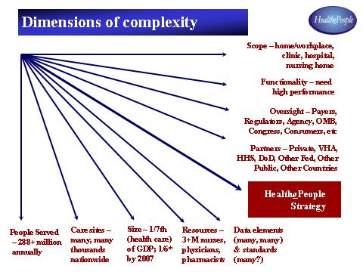

FIGURE 6 – DIMENSIONS OF COMPLEXITY

The demands on healthcare providers to have current and complete information in “real time” are intensifying. Healthcare providers must deal with an ever-growing, ever-changing body of medical knowledge. Patient demands and knowledge are increasing as availability and sources (e.g., the Internet) of information increase. People move from place to place and have emergency care needs as they travel. Care is being provided in a wide range of settings—hospitals, clinics, nursing homes, and in the community (e.g., home, workplace). And all this is occurring amid rising expectations for healthcare satisfaction, efficiency, quality, and outcomes.

The Institute of Medicine has called for paperless health information systems by the year 2010. (IOM, 2001) Many organizations, including the VA, are working to reach that goal, as shown in Figure 7. To achieve the widespread adoption of the paperless, high performance electronic health records and personal health records, we must have all the necessary components in place. Health data and communications standards must be adopted. Personal health record systems, electronic health record systems, and health information exchange must be available, affordable, standards-based, and high quality.

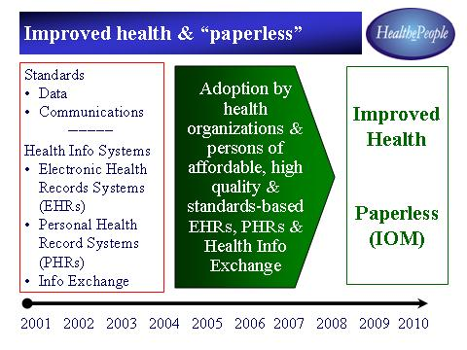

FIGURE 7 – IMPROVED HEALTH AND “PAPERLESS”

Until recently, the efforts of public and private sector healthcare organizations were disparate in nature, and the lack of standards made systems expensive to create and recreate. This situation is changing. New opportunities are emerging and being aggressively pursued. Today, key organizations in both sectors are developing or adopting the next generation of health information systems that are very similar. Both sectors have common needs and face common challenges; both have limited resources with which to execute their individual strategies.

Data Standardization: A Case in Point

In the private sector, healthcare organizations like Kaiser Permanente are working to “migrate” from multiple versions of clinical and demographic data to one national standard. In the public sector, the Department of Defense (DoD) is migrating its 104 variations of clinical data to one standard to support its Composite Health Care System (CHCS II). The Indian Health Service (IHS) has to migrate over 200 variations of clinical and demographic data to one standard. To support its HealtheVet strategy and its health data repository, the VA is migrating between 150 and 170 variations of clinical and demographic data to one standard. Other health organizations are making similar moves. Across the healthcare sector, these efforts pose tremendous challenges and consume scarce resources. Clearly, it would be preferable to move to one national or international set of data and communications standards and to deploy high performance health information systems.

The Tipping Point

Our country is at a tipping point, an opportune moment in history. Together, private and public sector health organizations can help change how health information and related systems support health delivery. Such change can transform health care in both the private and public sectors.

An immediate opportunity arises from the needs of payers to ensure that they are good stewards on behalf of the ultimate payers—taxpayers, employers/employees, and individuals. The largest of the major payers, the Centers for Medicare and Medicaid Services (CMS), has identified a great need for more information on health providers for their beneficiaries and on the quality and outcomes CMS is receiving for payments made. In partnership with VA and AHRQ, CMS is strongly encouraging the widespread adoption of health information standards, personal health records, information exchange, and electronic health records—the four components that make up HealthePeople.

Collaborative Efforts

Recognizing that they share common goals, many health organizations are supporting collaborations with other entities in the public and private sectors, including foundations, professional organizations, commercial technology companies, and state and local agencies. For example, there are the eHealth Initiative (eHI) and the Electronic Health Record Collaborative. In addition, there are the following:

Connecting for Health. Convened by the Markle Foundation, a New York-based philanthropy, Connecting for Health brought together over 100 public and private organizations representing every part of the healthcare system to advance standards, privacy and security practices, and personal health records.

Public-Private Electronic Health Record Initiative. Federal agencies, including the VA, CMS, and AHRQ, have joined with the American Academy of Family Physicians to campaign for the adoption of electronic health records, personal health records, and health information standards. The availability of affordable, standards-based, high quality EHRs in the private sector, including the one sponsored by the Academy of Family Physicians, and the VA’s HealthePeople-VistA will substantially increase their use in clinics, hospitals, nursing homes, community-based care, and integrated health systems. The widespread adoption of standards will enable the sharing health information, when authorized and appropriate. The availability of PHRs gives people and their health providers more capabilities to provide health support any place and any time.

Consolidated Health Informatics (CHI). This collaborative is a joint effort of federal agencies, including VA, DoD, and HHS (including CMS and FDA). Through its partnership with the National Committee for Vital and Health Statistics and its members, CHI has links to standards development organizations and health providers like Kaiser-Permanente. The initiative builds on the decisions of the VA and DoD, first, to move a single standard individually and, second, to go to a single standard for both. Thus, CHI is defining a common set of data and communications standards to be used across all federal health agencies, as shown in Table 2. The first five standards were jointly adopted in 2002 and an additional six standards were jointly adopted in 2004. These may prove to be the tipping point in the adoption of health data and communications standards across public and private health organizations nationally and internationally.

HealthePeople

HealthePeople is a collaborative strategy for helping accomplish this critical change. As its name declares, HealthePeople focuses on “Health,” not just medicine. It focuses on “People,” including beneficiaries, members, and patients. And it relies heavily on electronic means—the “e”—as a key enabler. Public and private sector organizations have been participating with this effort since 2001 and together are helping adopt health information standards and develop and deploy affordable, high performance health information systems.

Among HealthePeople’s goals are to do the following:

- Adopt national and international health information standards for health information systems.
- Make public and private sector high performance health information systems, including EHRs, more affordable, available, standards-based, and interoperable. As appropriate, provide health information system software (e.g., HealthePeople-VistA) to public organizations and to private sector organizations that serve the poor and near poor at as close to no cost as is possible.
- Make PHRs available to people and their healthcare providers that enable people to access and share their health records, access trusted health information and access key supportive services, including prescription drugs and appointments.
- Help develop a national solution to enable the appropriate and authorized health information exchange.

Part of the HealthePeople strategy is to advance on multiple fronts and collaborate with different federal partners. In one such effort, the VA is working jointly with the Department of Defense to:

- Improve sharing of health information.
- Adopt common standards for architecture, data, communications, security, technology and software.
- Seek joint procurements and/or build applications, where appropriate.
- Seek opportunities for sharing existing systems and technology.
- Explore convergence of VA and DoD health information applications consistent with mission requirements.
- Develop interoperable health records and data repositories.

In a second effort, the VA is building on its long-term partnership with the Indian Health Service (IHS). Converging on the same EHR (while still addressing unique IHS needs) and adopting common standards for data and communications will enable IHS to use current and future versions of the VA’s HealthePeople-VistA.

HealthePeople by 2010

The Strategy

In 2001, those of us working on HealthePeople and like efforts arrived at consensus as to the conditions necessary to a paperless, virtual health system, but we were still unclear what steps we needed to take to make it happen. Thanks to initiatives like those discussed in this chapter, an overall approach has emerged. From where we now stand, there is a fairly clear though challenging path to achieving this goal. HealthePeople and related efforts are bringing about needed changes. The progress being made now and the progress projected for the next five years make it possible to arrive at this goal by 2010, as laid out in Figure 8. But we cannot and do not underestimate the work that lies ahead. Electrifying 1/7th of the national economy is a huge but doable undertaking.

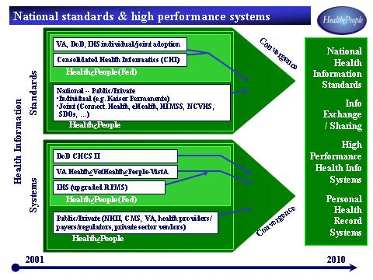

FIGURE 8 – NATIONAL STANDARDS AND HIGH PERFORMANCE SYSTEMS

The overall strategy requires that data and communications standards and high performance health information systems be in place. In 2003, the HealthePeople initiative focused on joint standards efforts, targeting the adoption of key standards by the federal sector no later than the end of 2004 and nationally shortly thereafter. The focus now is to make high performance systems, like VA’s current VistA and future HealthePeople-VistA system, fully operational by 2005. Along with several existing private sector EHRs, these VA systems demonstrate feasibility, deliver value, and offer “proof of concept.” According to the IOM, “VHA’s integrated health information system, including its framework for using performance measures to improve quality, is considered one of the best in the nation.” (
IOM, 2002)

To meet the ever-increasing demands of clinicians, payers, and regulators, even high performance systems need more enhancements. The overall strategy requires quickly moving PHRs from their current immature state, making several viable and available by the end of 2005. To make these components work together and move information, the approach also requires the creation of a health information exchange at the national level by the end of 2005.

Meeting these targets will rely upon much of the work already done or underway in the public and private sectors. By making affordable standards-based, high-performance EHRs and PHRs available, efforts like Connecting for Health and HealthePeople are helping “early adopting” health organizations put highly effective health information systems into place, here in the United States and beyond. Other collaborative efforts are advancing standards for communication of health records and for health data within health records. Once fully implemented, such standards will enable people and their healthcare providers and healthcare payers and regulators to secure and, when appropriate, share data.

Actions to Take

Achieving a virtual health system in the United States by the year 2010 requires that the components essential to HealthePeople are in place. We must do support efforts underway in the private sector and continuing initiatives ongoing in the VA, and we must do more. We must act now.

These are the actions we must take in critical areas:

Electronic Patient Records
- Strongly encouraging private sector vendors to make affordable, high quality, standards-based EHRs available
- Strongly encourage provider-based efforts like American Academy of Family Physicians (AAFP)
- Provide financial incentives to healthcare providers through differential payments and/or grants
- Continue to improve and make available HealthePeople-VistA

Personal Health Records
- Strongly encourage the public and private sectors to work together to develop PHRs and make them available to individuals
- Encourage primary healthcare providers to offer PHRs that individuals can operate on their home computers
- Support the development of PHRs by independent “vaulting” services or as a kind of “personal banking”
- Foster a public/private initiative to make PHRs available to Americans with limited or no ability to pay

Health Information Exchange
- Strongly encourage the public and private sectors to work together to develop and make available a national “exchange” solution
- Urge the development of a multilateral national exchange system to link the individual at the center of care with multiple providers and health organizations
- Encourage health providers to establish bilateral systems with colleagues with whom they have close, day-to-day working relationships

Standards
- Strongly encourage public/private development and adoption of national standards
- Assign the federal Consolidated Health Informatics (CHI) initiative a leadership role nationally and internationally

Security
- Strongly encourage public/private adoption of an “identifier,” most likely voluntary, to be used as telephone numbers or email addresses are now
- Build upon the experience of the banking community and the growing adoption of Health Level Seven (HL7) messaging
- Utilize established authorization and authentication systems to ensure only appropriately designated individuals exchange information
- Take advantage of the infrastructure provided by the Internet and the ability it gives us to securely move information across it

Moving toward 2010

Together, these actions will help us move toward virtual systems that provide
- More affordable, more available, higher performance electronic heath record systems and greater interoperability among such systems
- More available personal health record systems
- More adoption of national and international health information standards
- Easier, more secure health information exchange among people, healthcare providers, payers, and regulators when appropriate and authorized.

Beyond these actions, HealthePeople calls upon us to change how we deliver health care, to go beyond episodic care to care for the whole person and, ultimately, for entire populations. It requires that we develop and incorporate best practices into ideal health systems, and make the best possible use of technology.

If we do all these things, and do them well, we will create a virtual health system that contributes substantially to improving the health of people it serves, beginning with 26 U.S. veterans, and from there reaching out across the United States and around the world.

References

Institute of Medicine (IOM). 2002. Leadership by Example: Coordinating Government Roles in Improving Healthcare Quality. National Academy Press: Washington, DC.

